**4.Understand linux utility commands like - ping, arp (Understand each params from ifconfig output)**

**4.a.ping:**

* ping -c : Send a specific number of ping requests
* ping -i :Sets a definite time interval
* ping -s :Sets size of the packet
* ping -q :provides the summary of the packets transaction.

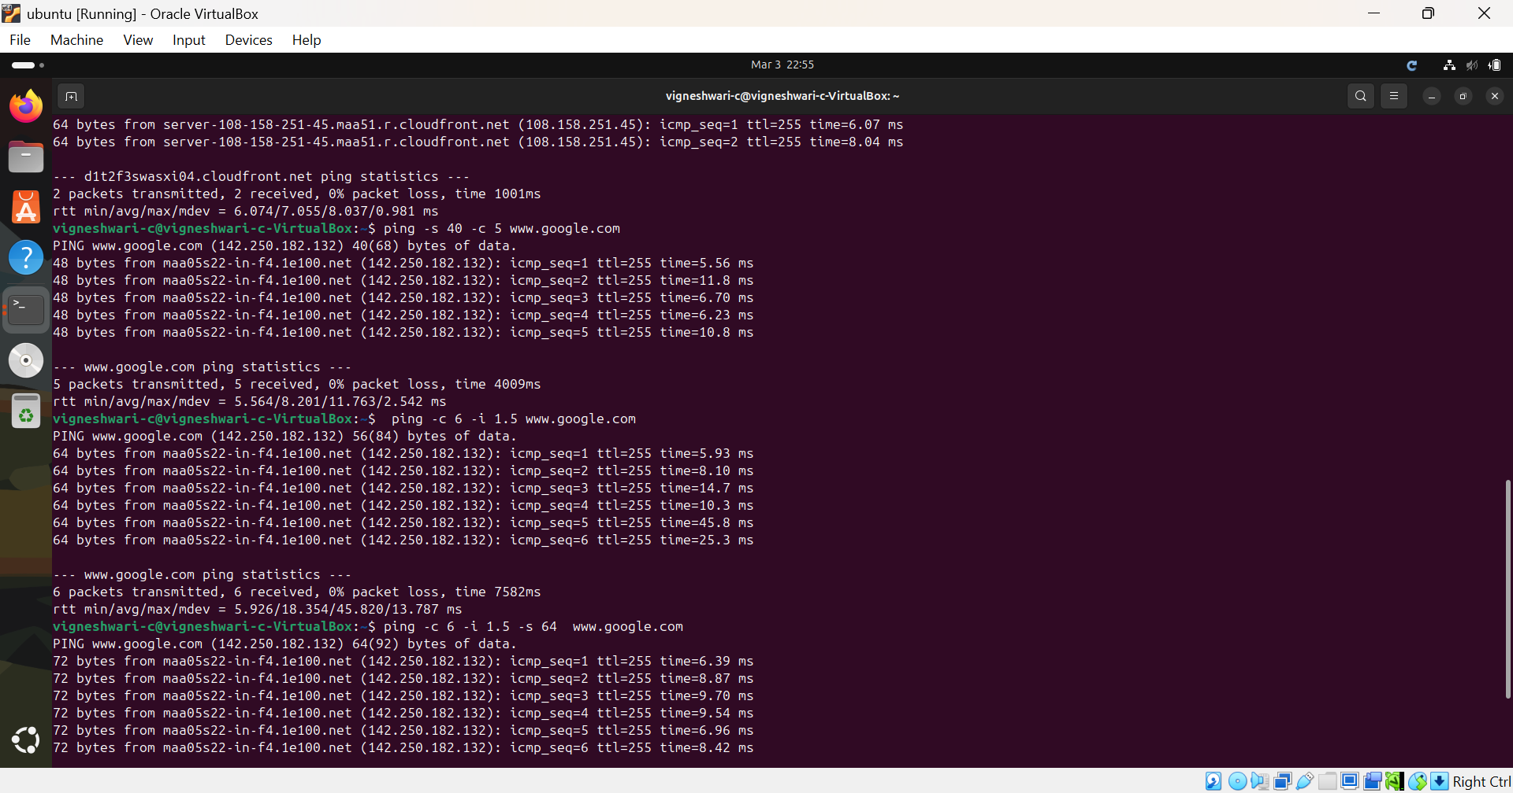



**4.b.arp:**

* arp -e / arp : To show the current entries in the ARP cache.
* arp -a : Display the ARP cache (IP address -> host names).
* arp -n: Show numerical addresses instead of resolving hostnames.
* arp -d : Delete an arp entry.
* arp -s : To add a static arp entry**.**

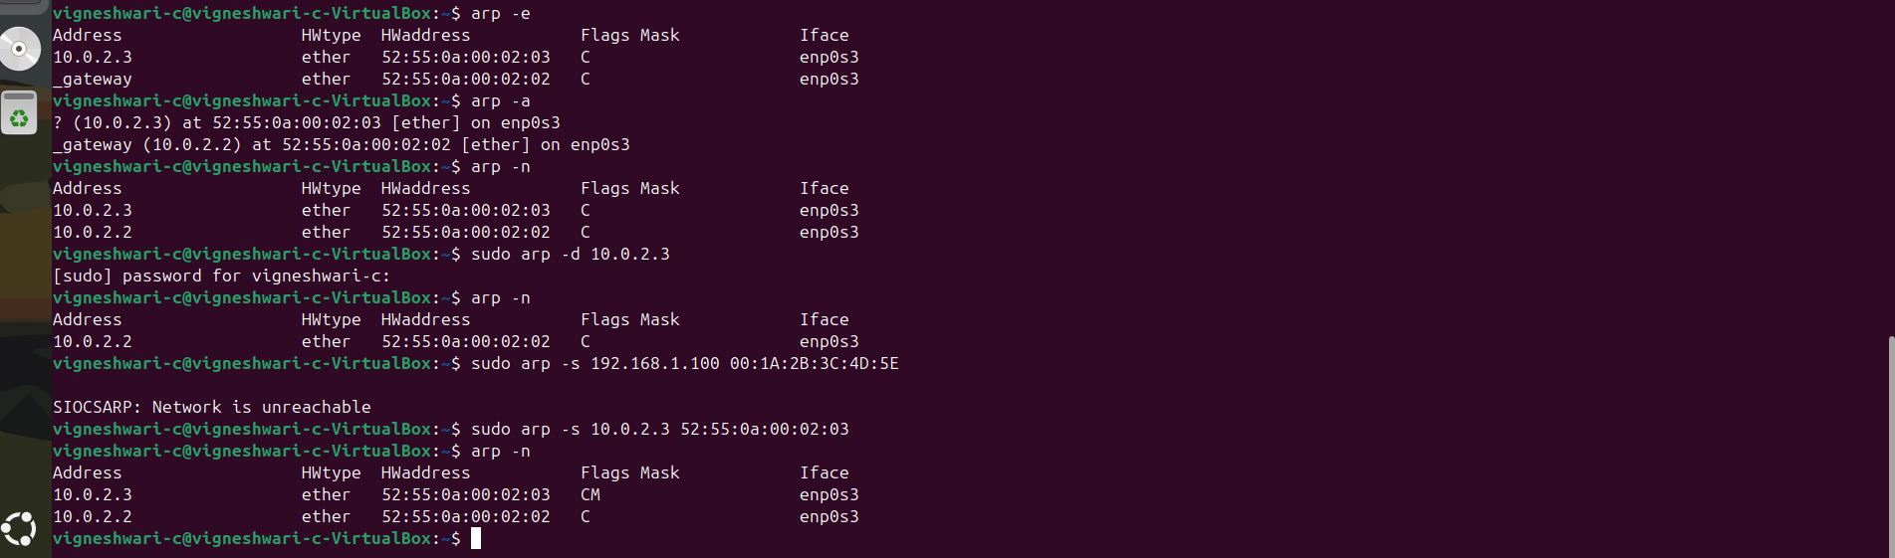

**4.c.ifconfig:**

* ifconfig : Show all active network interfaces.
* ifconfig enp0s3 : Show details of a specific interface.
* ifconfig enp0s3 up : Enable an interface.
* ifconfig enp0s3 down : Disable an interface.
* ifconfig enp0s3 192.168.1.100 : Assign an IP address to the network interface enp0s3.

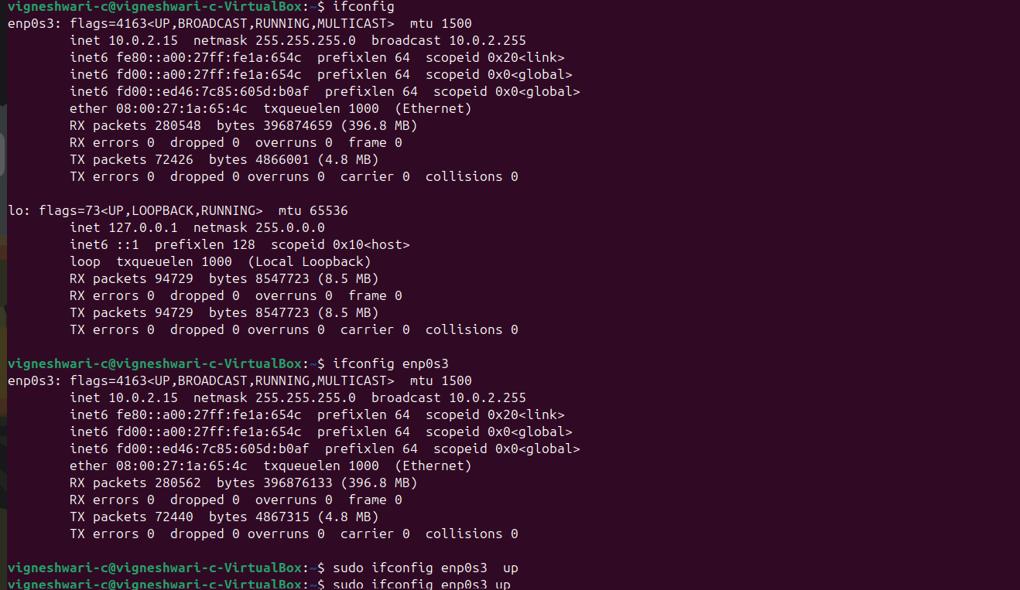

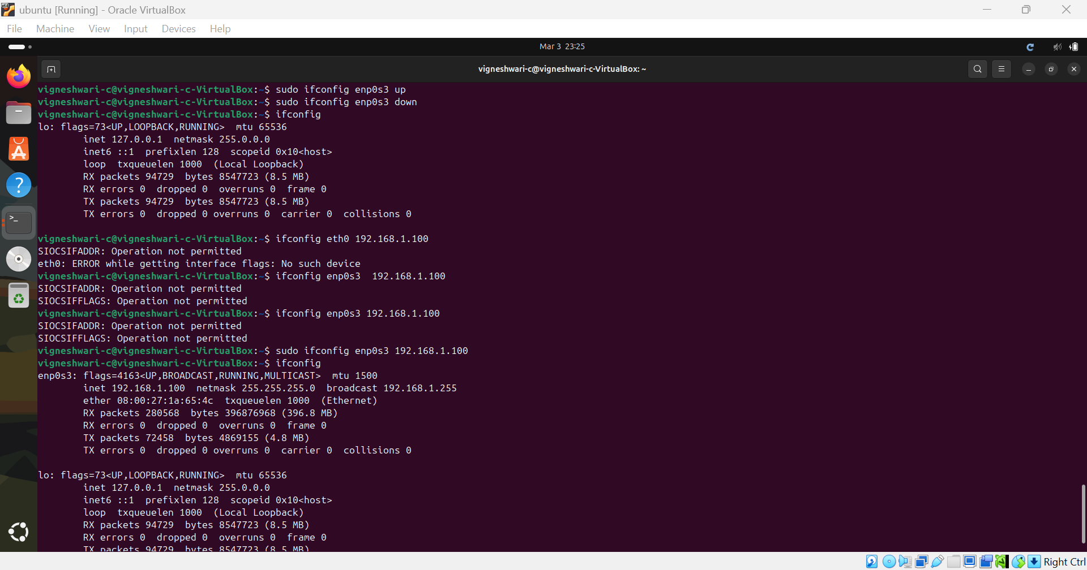

**Parameters in ifconfig:**

* Flags: Interface status -UP, LOOPBACK, RUNNING
* MTU(Maximum Transmission Unit) -65536 bytes
* IPv4 Address (inet)-Localhost IP address-127.0.0.1
* Subnet Mask (netmask)-Defines the network range-255.0.0.0
* IPv6 Address (inet6) IPv6 localhost ::1
* RX Packets-Received packets count-94729
* RX Bytes-Total data received-8.5 MB
* TX Packets-Transmitted packets count-94729
* TX Bytes-Total data sent-8.5 MB
* Errors, Drops, Overruns, Collisions (RX errors, TX errors, dropped, overruns, collisions) – 0 errors.